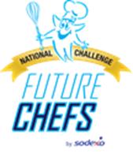

**Hi Kids,**

**Put your chef hat on and compete in the 2nd annual Future Chef Competition. All recipes must be submitted by January 17th. Below is only a glance of a couple of items that you can win for taking 1st prize.**



**We’re looking for your favorite Healthy comfort food recipe**

**PICK UP YOUR ENTRY FORM TODAY!**

They’re available in the front office & cafeteria!

Turn them in to the front office or cafeteria by January 17, 2017

One lucky winner from each grade 1st – 5th will be chosen as finalists to compete in our contest at Paradise Education School on February 15th, 2017. As an added bonus, the winner of this event will be entered into a national competition for some great prizes!